ENGSCI 355 Group 7 Project Report

By Jungwoo Han, Kevin Hu and Sihyun Um

**Problem Description**

A hospital would like to model three of its systems to determine how many staff it needs in each area to meet its performance targets. These three systems are: the emergency department (ED), the patient transit (PT) and the wards. The Emergency Department is responsible for registering, triaging, and consulting patients that need urgent care. The patient transit system moves the patients around the hospital and the patients that need longer term care stay in the ward.

**Data analysis and Processing**

**Overview of Process**

The built-in Fitter function is used to find appropriate time distribution of arrival or service time of active entities on each section. The supplied historical data of patient and orderly was in undesired data form and therefore data cleaning is performed.

To extract useful information out of the data provided, it was first converted into DataFrame in Python to have easy access to each attribute. This allows access to patient and orderly data by their unique ID. In this way, all of relevant inter-arrival and service times are computed iteratively by finding the difference of two corresponding events and values are recorded in the separate list objects. These are then transformed into Numpy Array to fit a number of different distributions, including Lognormal, Normal, Exponential and Uniform distribution as shown in figure 1.

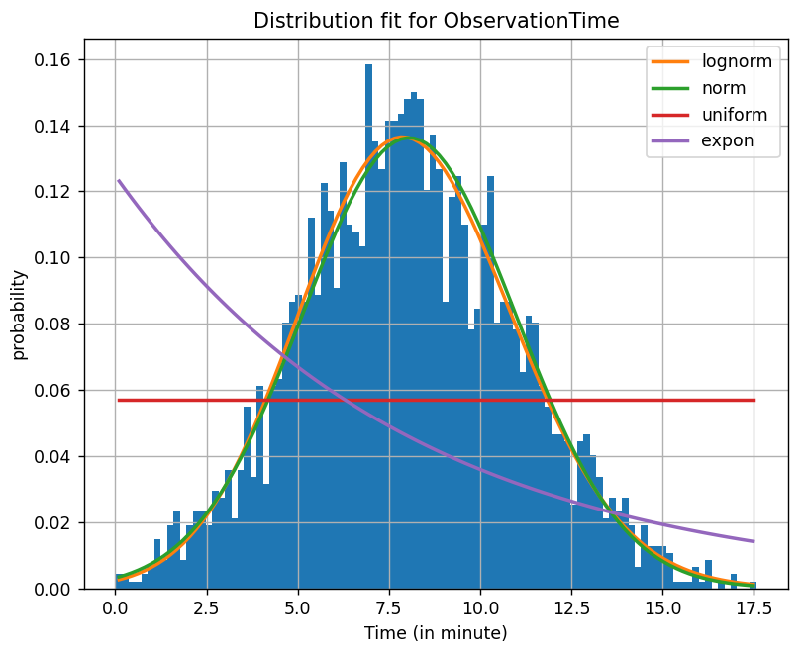

**Figure 1: Result of fitting number of different distributions**

Some service time did not correspond to any of the distributions mentioned earlier. In such cases, their time distribution is examined by the shape of histogram and an appropriate distribution is determined.

It is also provided that patients are heading to one of 12 pathways before completely leaving the hospital system. A discrete probability distribution is fitted to these pathways. Patient’s attributes including TriageCategory, AmbulanceArrival, RequireTest and WardAdmission are calculated from the pathway with corresponding index. Because the activity diagram only classifies the patient’s category into either $≤$ 2 or >2, a binary value is assigned for a patient's category upon generation (either 1 or 3), instead of a value between 1 and 5.

**Summary of distributions**

The summary of time distributions are as shown below.

|  |  |  |  |
| --- | --- | --- | --- |
| Distribution | Section | Data | Parameters |
| Normal | ED  ED  Wards  Wards  Wards | ObservationTime  TestResultsTime  ObservationTime  AdmissionTime  DischargeTime | **(min value, mean, standard deviation)**  **(0, 8.052, 2.929) in minute**  **(0, 104.0, 20.81) in minute**  **(0, 13.95, 4.028) in minute**  **(0, 8.137, 1.976) in minute**  **(0, 8.115, 1.960) in minute** |
| Lognormal | ED  ED  Wards | TriageTime  ConsultationTime  TestTime | **(min, NormalStandardDeviation, NormalMean, Scale)**  **(5.083, 0.2870, 0.1349, 7.853) in minute**  **(6.73, 0.5865, 0.05932, 27.40) in minute**  **(0, 0.3467, 0.2460, 26.39) in minute** |
| Exponential | ED  PT  PT  PT  PT  PT  Wards | InterArrivalTime  PickupTime  DropoffTime  TravelTime   * Base to Ward * Base to ED * Ward to ED   WardStayTime | **( mean)**  **(0.1204) in hour**  **(5.011) in minute**  **(4.913) in minute**  **(12.63) in minute**  **(8.100) in minute**  **(13.54) in minute**  **(41.40) in hour** |
| Discrete | Hospital  System | PathwayIndex | **(Pathway index: probability)**  **(1:0.398), (2:0.035), (3:0.041), (4:0.269),**  **(5:0.023), (6:0.024), (7:0.080), (8:0.015),**  **(9:0.041), (10:0.048), (11:0.010), (12:0.017)** |
| Uniform | ED | RegistrationTime | **(min, max)**  **(5.0, 10.0) in minute** |
| Constant | PT | DropWaitTime | **(Constant value)**  **(20.0) in minutes** |

**Table 1: Summary of time distributions**

**Experiment performed**

We set up a warm up duration of 2 days for our model to reach steady state, followed by 7 days of running period. 10 replications were made to obtain valid statistics from our simulation result. In each simulation, we configure a different number of staff to meet the requirements at three areas of the hospital system.

It was also thought that it is inefficient for orderly to have a waiting time of 20 minutes (obtained from historical data) after dropping off patients. So, we simulate through the smaller value of this waiting time to find out if there is any difference to the result.

**Result**

When having 20 nurses and 7 doctors in ED, 6 orderlies in PT and finally, 7 nurses and 3 technicians in Wards, we were able to meet the criteria. That is:

* The time between arrival to the ED and either being discharged from the ED or finishing being admitted to a ward, should be less than 6 hours and 95% of patients are spending less than 3 hours and 26 minutes.
* The time between needing to be observed and starting an observation in the ED, should be less than 2 minutes on average and the resulting average is 1 minute and 42 seconds.
* The time between requesting a transit and starting being picked up should be less than 20 minutes on average and the resulting average is 15 minutes and 10 seconds.
* The time between needing to be observed and starting an observation in the Wards should be less than 15 minutes and patients are spending less than 14 minutes for 95% of the time.
* The time spent waiting for a test should be less than 5 minutes on average and the resulting average is 4 minutes and 29 seconds.

Further decrease in the number of staff in any of areas in the hospital system lead to one or more calculated waiting times above, exceeding the requirement.

Furthermore, the decrease in waiting time of orderly (after the dropoff) improved the result. When the waiting time is set to 10 minutes with the number of staff mentioned above (6), the time patients wait for orderly reduces to 14 minutes and 38 seconds on average but increases to 17 minutes and 50 seconds if the orderly returns to the base immediately. However, when the number of orderly decreased from 6 to 5, this average time ended up exceeding the requirement of 20 minutes.

**Conclusions and Recommendations**

As a result, we recommend having 7 doctors and 20 nurses for the ED system, 6 orderlies for the PT system and 7 nurses and 3 technicians for Ward system to be able to meet the performance targets of patients spending their time waiting in the hospital while minimising the number of staff. It is also recommended to change the waiting time of orderies (after the dropoff) to 10 minutes to ensure less waiting time for patients before the transit begins.